Polynomials

The assignment is to write a program that adds or multiplies any two polynomial expressions. Also have it evaluate the polynomial expression at any given point.

1) What’s a polynomial expression? Write several concrete examples.

2) Should we put some restrictions on the kinds of polynomials that we will allow?

3) For any given polynomial, what information is essential?

4) How will we model each polynomial? That is, how will we store the essential information?
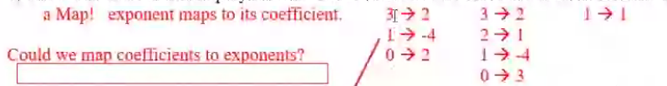

5) We need some sort of collection of coefficients paired with exponents. We could use parallel arrays. We could use one array, in which the exponents are the indexes. We could also map integers to integers. If we did that, which is the key and which is the value? Should we use hashmaps or treemaps?

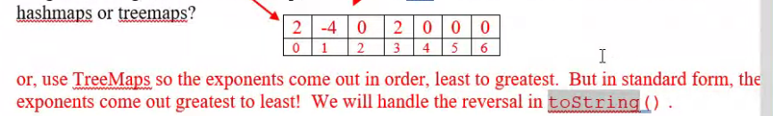

6) We could just make a driver, instantiate three maps (two for input and one for output), and implement the operations as static methods. Alternatively, we could write a polynomial class and instantiate three polynomial objects, each with its private map and instance methods. The latter is better if we want to use the polynomial class in other situations. Declare the private field in the Polynomial class here:

7) So what does the Polynomial class need to do? Write an interface, not because it is necessary, but because it provides a guide to our programming. “The sooner you start to code, the longer the program will take.”

8) What kind of constructor(s) for the Polynomial class do we need?

9) How about testing our class? That is, what driver program do we need? Make up the values for two specific polynomials, add them, and print the result. Then write the code.

10) What is the expected output?

11) Notice we did 10 things before we even thought about algorithms. What is the algorithm for toString?
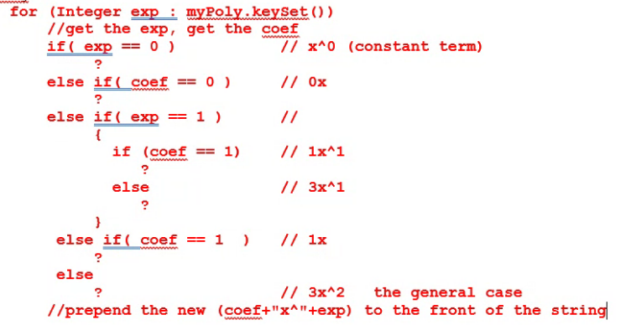

12) What is the algorithm for evaluateAt(double x) ?

13) What is the algorithm for add(Polynomial other) ?

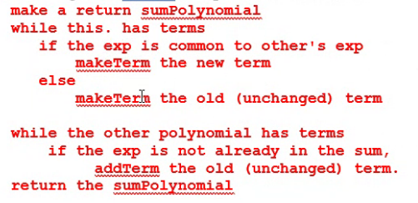

14) What is the algorithm for multiply(Polynomial other) ?
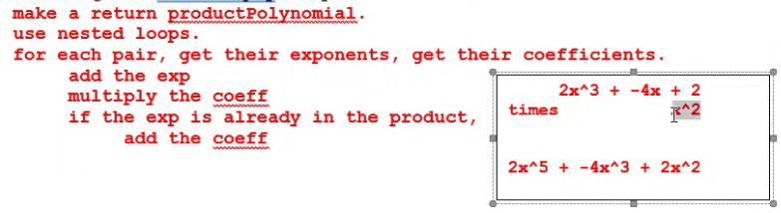

15) Your Polynomial class will need access the other’s map, which of course is private. You could write an accessor method. However, the Java designers decided to make private private at the class level, not at the object level. Thus, your Polynomial class already has direct access to the other’s private map. Take advantage of it.

